**Objectives**

* Demonstrate integration of RESTful Web Service of type GET and test the service using postman.
  + REST Web Service architecture with Controller, Service and Dao, service methods.

NOTE: There is no Quiz for this session

**Problem Statement - Display Employee List and Edit Employee form using RESTful Web Service**   
  
In the previous angular module, we developed a screen that lists employees and it was populated with hard coded values. Now this angular application has be changed to get the data from RESTful Web Service developed in Spring. The following are the high level activities that needs to be done to accomplish this: 

* Create static employee list data using spring xml configuration

* Create a REST Service that reads data from xml configuration and returns it

* Make changes in angular component to consume the created REST Service

Once above activities are completed, clicking on the Edit button against each employee should display Edit Employee form with values retrieved from RESTful Web Service. This will also involve activities similar to the one specified above.  
  
NOTE: There is no specific activity as part of this hands on, refer the next hands ons that covers above three activities in detail.

**Create static employee list data using spring xml configuration**   
  
Follow steps below to accomplish this activity: 

* Incorporate the following in employee.xml:
  + Create one or two more departments
  + Create four more instances of Employee.  (use employee sample data from angular)
  + Reuse existing skills instead of creating new ones
  + Include all four employee instances in an ArrayList.

* In EmployeeDao, incorporate the following:
  + Create static variable with name EMPLOYEE_LIST of type ArrayList<Employee>
  + Include constructor that reads employee list from xml config and set the EMPLOYEE_LIST
  + Create method getAllEmployees() that returns the EMPLOYEE_LIST

Employee.java

package com.cognizant.spring_learn.model;

import java.util.Date;

import java.util.List;

public class Employee {

private int id;

private String name;

private double salary;

private boolean permanent;

private Date dateOfBirth;

private Department department;

private List<Skill> skillList;

// Getters and Setters

public int getId() { return id; }

public void setId(int id) { this.id = id; }

public String getName() { return name; }

public void setName(String name) { this.name = name; }

public double getSalary() { return salary; }

public void setSalary(double salary) { this.salary = salary; }

public boolean isPermanent() { return permanent; }

public void setPermanent(boolean permanent) { this.permanent = permanent; }

public Date getDateOfBirth() { return dateOfBirth; }

public void setDateOfBirth(Date dateOfBirth) { this.dateOfBirth = dateOfBirth; }

public Department getDepartment() { return department; }

public void setDepartment(Department department) { this.department = department; }

public List<Skill> getSkillList() { return skillList; }

public void setSkillList(List<Skill> skillList) { this.skillList = skillList; }

@Override

public String toString() {

StringBuilder skillsBuilder = new StringBuilder();

for (Skill skill : skillList) {

skillsBuilder.append("\n\t\t").append(skill);

}

return String.format(

"""

Employee Details:

ID: %d

Name: %s

Salary: %.2f

Permanent: %b

Date of Birth: %s

Department: %s

Skills:%s

""",

id, name, salary, permanent, dateOfBirth, department, skillsBuilder.toString()

);

}

}

Skill.java

package com.cognizant.spring_learn.model;

public class Skill {

private int id;

private String name;

// Getters and Setters

public int getId() { return id; }

public void setId(int id) { this.id = id; }

public String getName() { return name; }

public void setName(String name) { this.name = name; }

@Override

public String toString() {

return String.format("Skill [ID=%d, Name=%s]", id, name);

}

}

Department.java

package com.cognizant.spring_learn.model;

public class Department {

private int id;

private String name;

// Getters and Setters

public int getId() { return id; }

public void setId(int id) { this.id = id; }

public String getName() { return name; }

public void setName(String name) { this.name = name; }

@Override

public String toString() {

return String.format("Department [ID=%d, Name=%s]", id, name);

}

}

EmployeeDao.java

package com.cognizant.spring_learn.dao;

import java.util.List;

import com.cognizant.spring_learn.model.Employee;

public class EmployeeDao {

private List<Employee> employeeList;

public void setEmployeeList(List<Employee> employeeList) {

this.employeeList = employeeList;

}

public List<Employee> getAllEmployees() {

return employeeList;

}

}

SpringLearnApplication.java

package com.cognizant.spring_learn;

import java.util.List;

import org.slf4j.Logger;

import org.slf4j.LoggerFactory;

import org.springframework.context.support.ClassPathXmlApplicationContext;

import com.cognizant.spring_learn.dao.EmployeeDao;

import com.cognizant.spring_learn.model.Employee;

public class SpringLearnApplication {

    private static final Logger LOGGER = LoggerFactory.getLogger(SpringLearnApplication.class);

    public static void main(String[] args) {

        try (ClassPathXmlApplicationContext context = new ClassPathXmlApplicationContext("employee.xml")) {

            LOGGER.info("=== Starting SpringLearnApplication ===");

            EmployeeDao employeeDao = (EmployeeDao) context.getBean("employeeDao");

            LOGGER.info("=== EmployeeDao Bean Retrieved ===");

            List<Employee> employeeList = employeeDao.getAllEmployees();

            for (Employee employee : employeeList) {

                if (LOGGER.isInfoEnabled()) {

                    LOGGER.info(employee.toString());

                }

            }

        }

    }

}

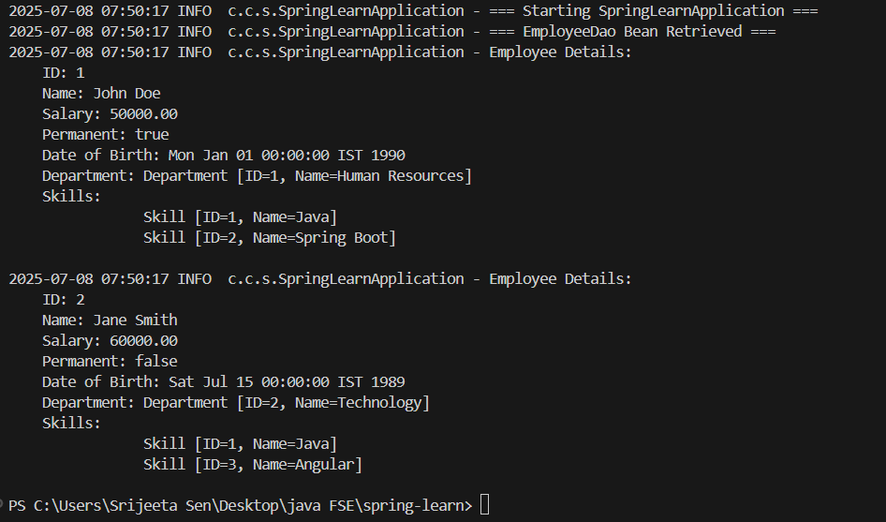

**Create REST service to gets all employees**   
  
Follow steps below to accomplish this activity:  

* In EmployeeService, incorporate the following:
  + Change the annotation for this class from @Component to @Service
  + Create method getAllEmployees() that invokes employeeDao.getAllEmployees() and return the employee list
  + Define @Transactional annotation for this method.

* In EmployeeController, incorporate the following:
  + Include a new get method with name getAllEmployees() that returns the employee list
  + Mark this method as GetMapping annotation with the URL as '/employees'
  + Within this method invoke employeeService.getAllEmployees() and return the same.

​​​​​​

* Test ​the service using postman.

EmployeeService.java

package com.cognizant.spring_learn.service;

import java.util.List;

import org.springframework.beans.factory.annotation.Autowired;

import org.springframework.stereotype.Service;

import org.springframework.transaction.annotation.Transactional;

import com.cognizant.spring_learn.dao.EmployeeDao;

import com.cognizant.spring_learn.model.Employee;

@Service

public class EmployeeService {

    private final EmployeeDao employeeDao;

    @Autowired

    public EmployeeService(EmployeeDao employeeDao) {

        this.employeeDao = employeeDao;

    }

    @Transactional

    public List<Employee> getAllEmployees() {

        return employeeDao.getAllEmployees();

    }

}

EmployeeController.java

package com.cognizant.spring_learn.controller;

import java.util.List;

import org.springframework.beans.factory.annotation.Autowired;

import org.springframework.web.bind.annotation.GetMapping;

import org.springframework.web.bind.annotation.RestController;

import com.cognizant.spring_learn.model.Employee;

import com.cognizant.spring_learn.service.EmployeeService;

@RestController

public class EmployeeController {

    @Autowired

    private EmployeeService employeeService;

    @GetMapping("/employees")

    public List<Employee> getAllEmployees() {

        return employeeService.getAllEmployees();

    }

}

Output

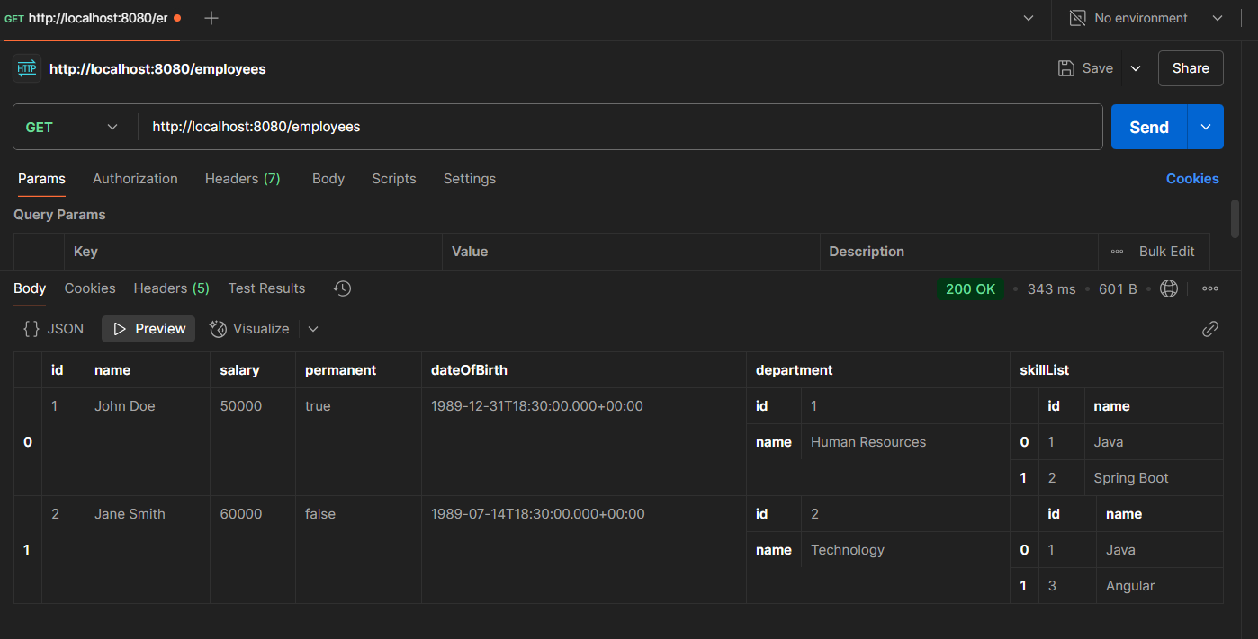

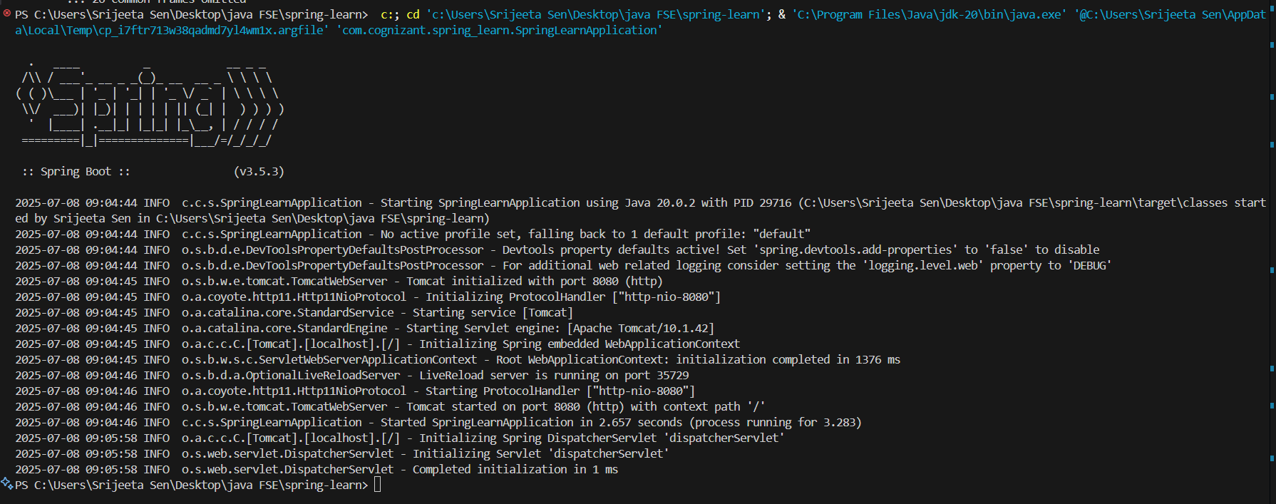

**Create REST service for department**

Create a new service to get all the departments.

Follow steps below to achieve this:

* Create a new REST Service, define below list of classes and respective methods:
  + DepartmentController
    - getAllDepartments() with URL "/departments", this method will return array of departments
  + DepartmentService
    - getAllDepartments()
  + DepartmentDao
    - getAllDepartments() - Create a static variable DEPARTMENT_LIST, this should be populated from spring xml configuration
* Test ​the service using postman.
* Also verify if department REST service is called by looking into the logs.

DepartmentController.java

package com.cognizant.spring_learn.controller;

import java.util.List;

import org.slf4j.Logger;

import org.slf4j.LoggerFactory;

import org.springframework.beans.factory.annotation.Autowired;

import org.springframework.web.bind.annotation.GetMapping;

import org.springframework.web.bind.annotation.RestController;

import com.cognizant.spring_learn.model.Department;

import com.cognizant.spring_learn.service.DepartmentService;

@RestController

public class DepartmentController {

    private static final Logger LOGGER = LoggerFactory.getLogger(DepartmentController.class);

    @Autowired

    private DepartmentService departmentService;

    @GetMapping("/departments")

    public List<Department> getAllDepartments() {

        LOGGER.info("Department REST service called");

        return departmentService.getAllDepartments();

    }

}

DepartmentDao.java

package com.cognizant.spring_learn.dao;

import java.util.List;

import com.cognizant.spring_learn.model.Department;

public interface DepartmentDao {

    List<Department> getAllDepartments();

}

DepartmentDaoImpl.java

package com.cognizant.spring_learn.dao;

import java.util.List;

import org.springframework.beans.factory.annotation.Autowired;

import org.springframework.stereotype.Repository;

import com.cognizant.spring_learn.model.Department;

@Repository

public class DepartmentDaoImpl implements DepartmentDao {

    private final List<Department> departmentList;

    @Autowired

    public DepartmentDaoImpl(List<Department> departmentList) {

        this.departmentList = departmentList;

    }

    @Override

    public List<Department> getAllDepartments() {

        return departmentList;

    }

}

DepartmentService.java

package com.cognizant.spring_learn.service;

import java.util.List;

import com.cognizant.spring_learn.model.Department;

public interface DepartmentService {

    List<Department> getAllDepartments();

}

DepartmentServiceImpl.java

package com.cognizant.spring_learn.service;

import java.util.List;

import org.springframework.beans.factory.annotation.Autowired;

import org.springframework.beans.factory.annotation.Qualifier;

import org.springframework.stereotype.Service;

import com.cognizant.spring_learn.dao.DepartmentDao;

import com.cognizant.spring_learn.model.Department;

@Service

public class DepartmentServiceImpl implements DepartmentService {

    private final DepartmentDao departmentDao;

    @Autowired

    public DepartmentServiceImpl(@Qualifier("departmentDaoImpl") DepartmentDao departmentDao) {

        this.departmentDao = departmentDao;

    }

    @Override

    public List<Department> getAllDepartments() {

        return departmentDao.getAllDepartments();

    }

}

